**Assignment 8: Implement Backward Chaining Algorithm**

**Problem Statement**

The objective of this assignment is to implement the Backward Chaining algorithm, which is used to answer specific queries from a knowledge base. This technique is essential for goal-driven reasoning, allowing systems to infer information based on established facts and rules.

**Objectives**

* Understand the principles of goal-driven reasoning.
* Implement the Backward Chaining algorithm for knowledge inference.

**Theory**

**What is Backward Chaining?**

Backward Chaining is a reasoning method that starts with a specific goal or query and works backward to determine which facts or rules support that goal. This approach is particularly useful in systems where specific answers are sought from a broader knowledge base.

**Methodology**

1. **Start with a Goal Query**:
   * Define the goal or query that you want to prove or answer based on the existing knowledge base.
2. **Identify Rules that Can Satisfy the Goal**:
   * Examine the rules in the knowledge base to find those that can lead to the goal. A rule is generally structured as "If premises, then conclusion."
3. **Work Backward to Find Supporting Facts for the Rules**:
   * For each rule identified, check if the premises can be satisfied by known facts or other rules. This may involve further queries.
4. **Continue Until the Goal is Proven or No More Rules Can Be Applied**:
   * If the premises are satisfied, the goal is proven. If no more applicable rules can be found, or if the premises cannot be satisfied, the proof fails.

**Working Principle / Algorithm**

Here’s a simple outline of the Backward Chaining algorithm:

1. **Initialize the Knowledge Base**:
   * Represent known facts and inference rules. For example:
     + **Facts**: F1,F2,…,FnF_1, F_2, \ldots, F_nF1​,F2​,…,Fn​
     + **Rules**: If AAA then BBB.
2. **Define the Goal Query**:
   * Specify the goal you want to prove (e.g., GGG).
3. **Check for Known Facts**:
   * If GGG is a known fact, return true.
4. **Search for Relevant Rules**:
   * For each rule in the knowledge base, check if GGG matches the conclusion of any rule.
   * If a matching rule is found, recursively apply the algorithm to its premises.
5. **Return the Result**:
   * If all premises are satisfied (i.e., proven true), then GGG is also true. If any premise fails to be satisfied, backtrack and try other rules.

**Advantages**

* **Efficiency**: Backward chaining is efficient for goal-driven systems, as it focuses only on relevant information needed to prove the goal.
* **Dynamic Queries**: It allows for dynamic querying, making it flexible for various inquiries based on the knowledge base.

**Disadvantages / Limitations**

* **Dynamic Knowledge Handling**: May not handle dynamic knowledge well since it relies on existing facts and rules.
* **Complexity in Large Knowledge Bases**: If the knowledge base is large and complex, determining applicable rules may become computationally intensive.

**Diagram**

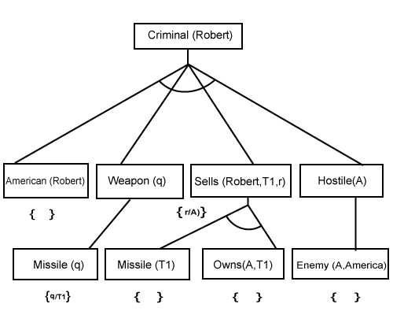 **Conclusion**

Backward chaining is a powerful technique for goal-driven reasoning, effectively answering specific queries from a knowledge base. It emphasizes the necessity of known facts and rules while focusing on proving desired conclusions.